10/23/2025: Notes for Cristian:

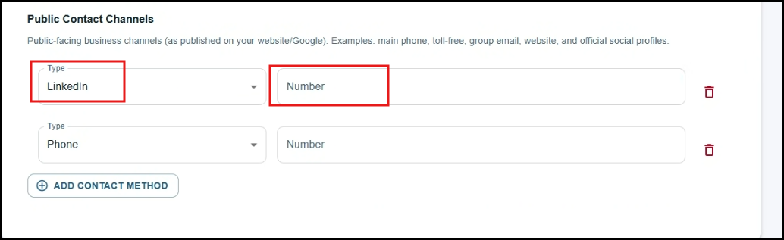
- Field should reflect the type (LinkedIn should have the @ for the profile/handle)

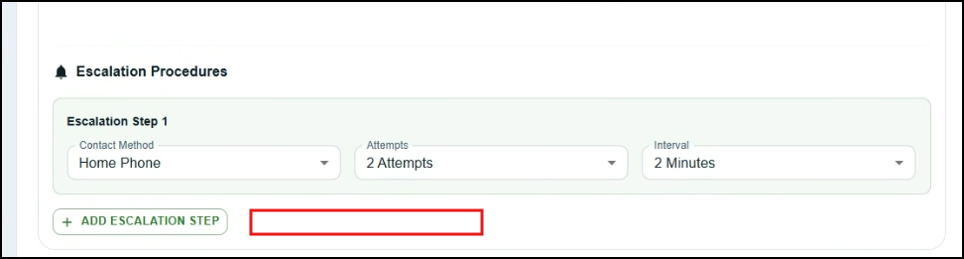
- Add ‘apply these to all contacts’

Rename this to say ‘Team Members’ (first box), Teams and 3rd box is Escalation Plan
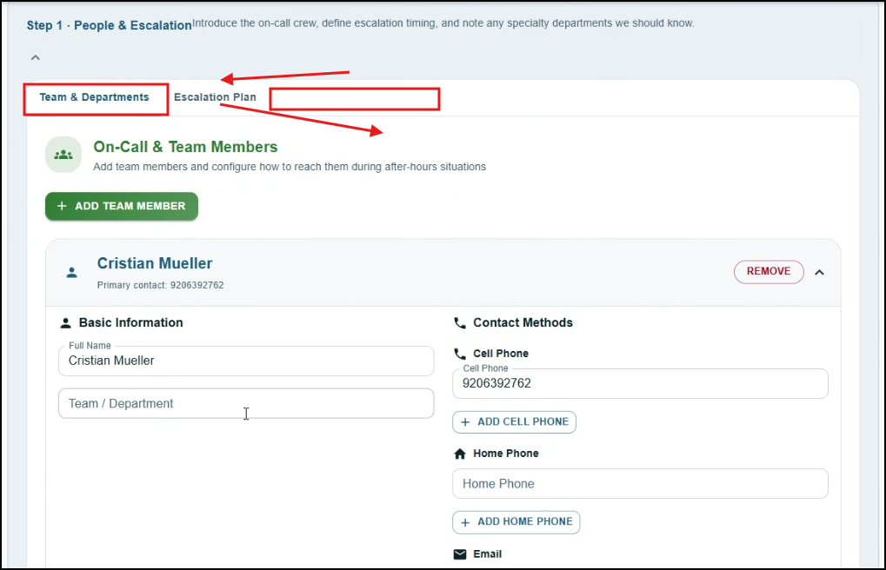

10/30/2025 Notes for Cristian:
Remove the ‘Team default contact’ since this is being covered in the ‘escalation list’ anyway
- 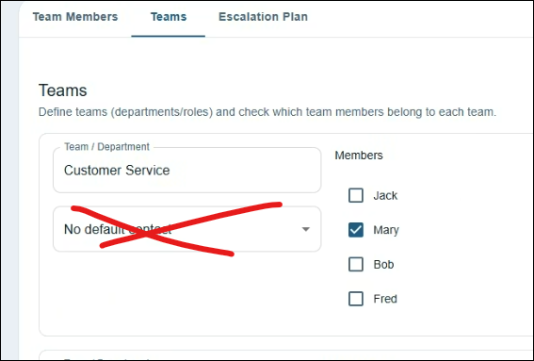

Escalation Plan:
- Client to fill out the types of calls that they receive in the beginning of the portal
  - How do you identify/clarifying question asked to confirm it IS this type of call
- We have them then identify the teams and teammates
- We then have them get to the “coverage summary & schedule section”
  - Escalation Plan: will have list of types of calls filled out earlier
    - Will then have system ask if we should ‘reach all team members, reach teamname+o/c, auto email or hold for morning cue
    - Note: if auto email: no further steps or asking how to further handle
    - Note: if morning cue – what time is that cue

OnCall Schedule/Shift Set up
- How often does your on-call change?
  - Daily, weekly, monthly - Include time ranges
- How many on-calls in this group?
  - Primary/Backup/10people

12/11/2025 Notes:
- Continuing with Escalation Plan & OnCall Schedule /Shift Set Up Notes above
- Cristian to disable this module
  - 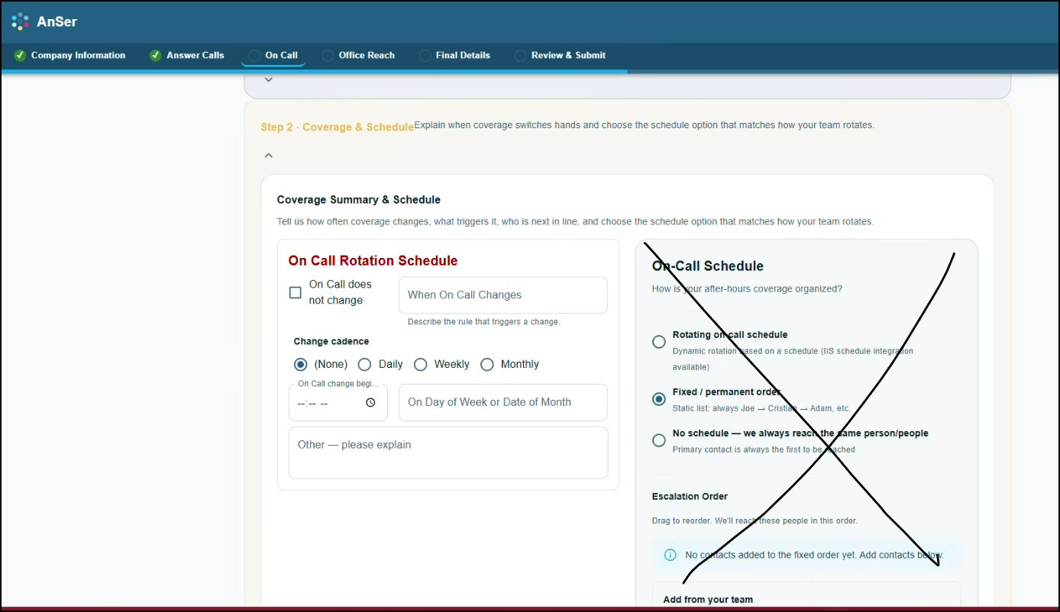
  - 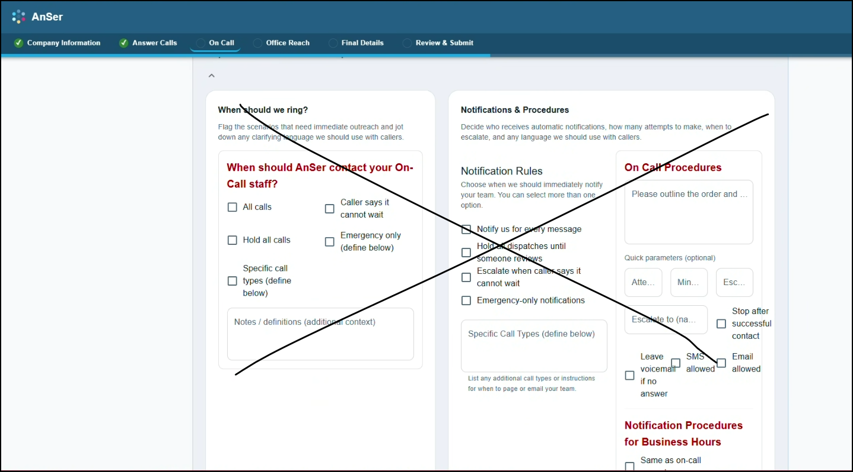
  - 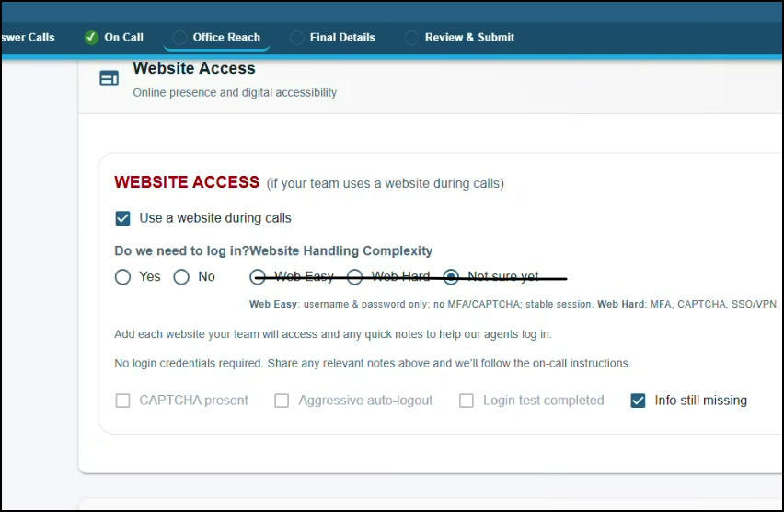
- Add this
  - 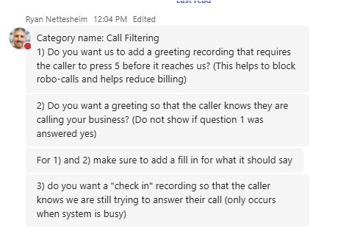

- 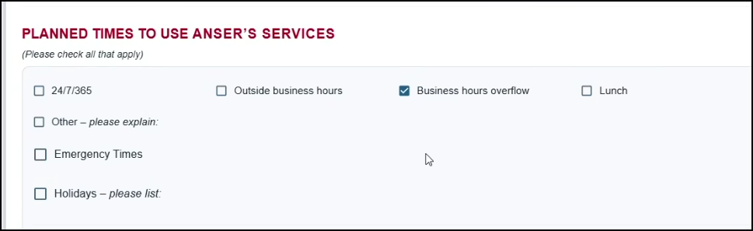

- Final Details should include:
  - Recap if email as taken was not selected
  - Holiday greetings
  - Auto Answers/Greetings
  - MiTeamWeb for O/C

